Assignment 2

Perform the Extraction Transformation and Loading (ETL) process to construct the database in the Sql server.

Procedure:

Step 1) Open SQL Server Management Studio to restore backup file

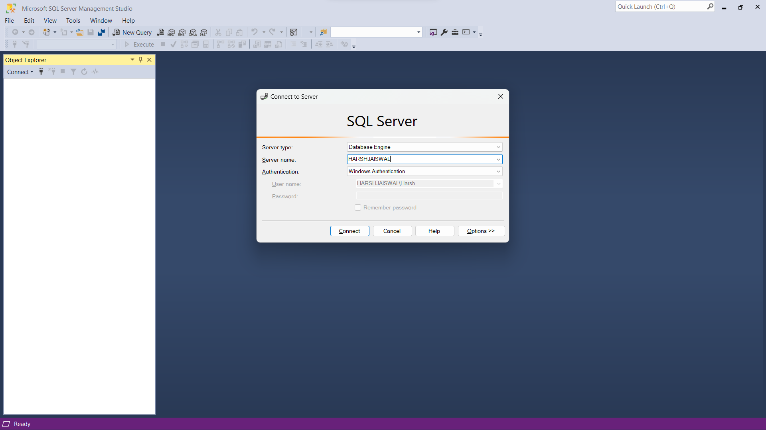

Step 2) Right Click on Database -> Restore Database

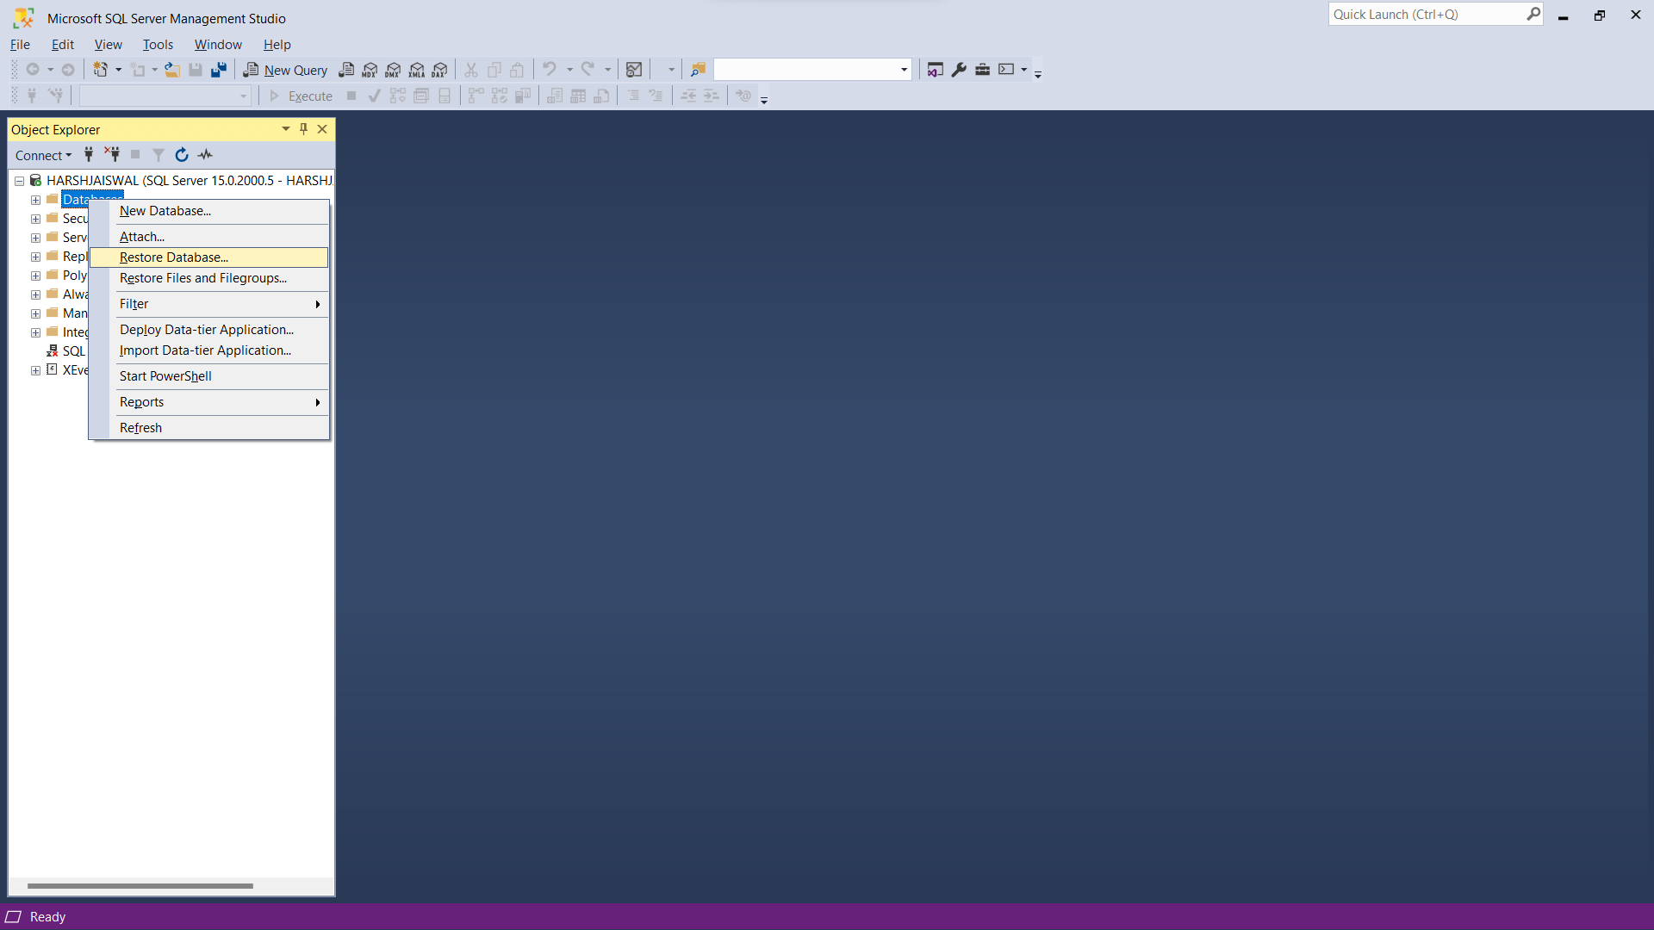

Step 3) Select device -> Click on … icon towards end of the device box, and click add

Step 4) In C drive make a folder BI and add the files the files attached to the repo folder “AdventureWorks2012.bak” and “AdventureWorksDW2012.bak”.

Step 5) Select path of backup files, select both files at a time, click ok

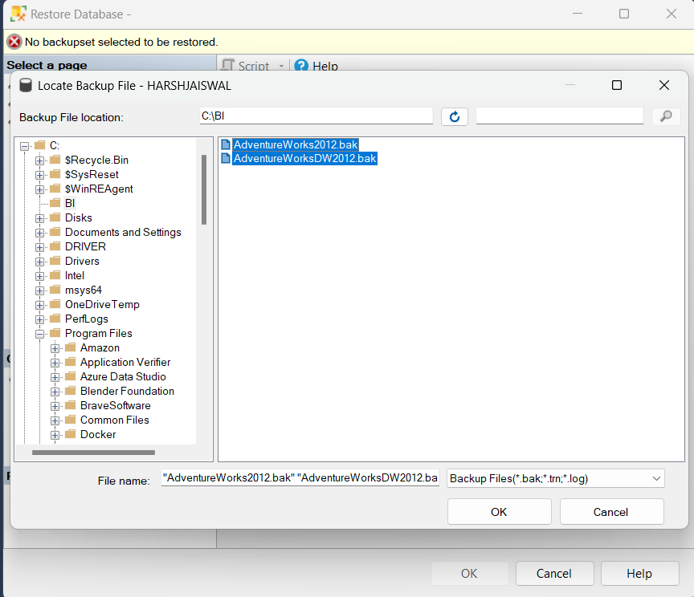

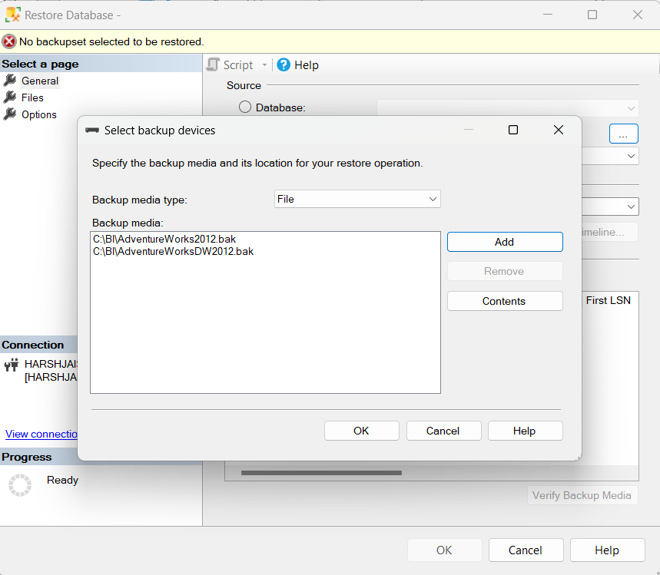

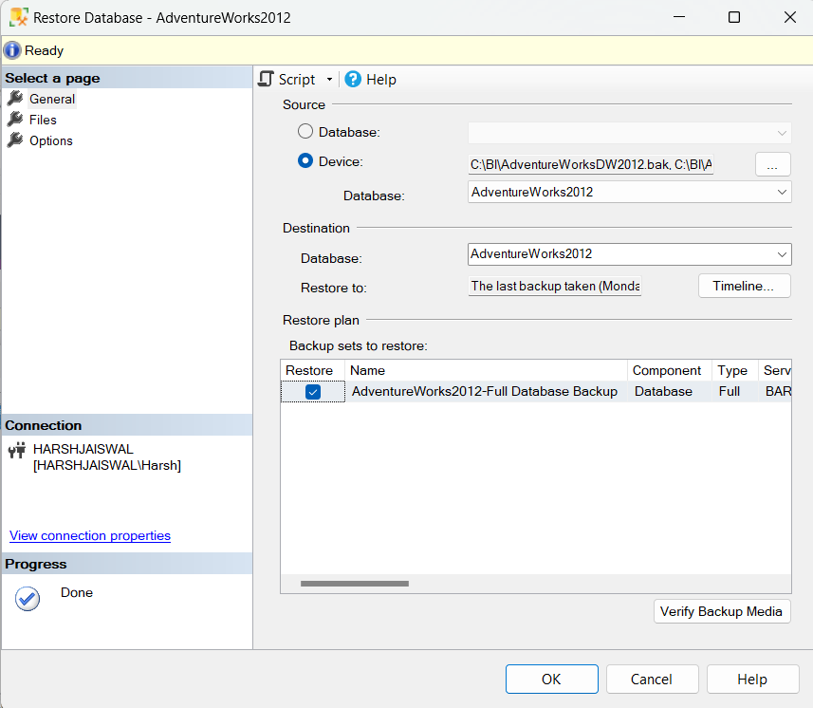

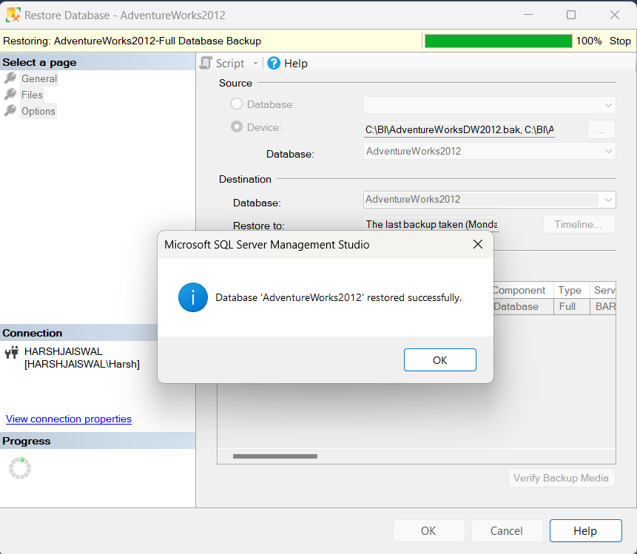

Step 6) Install SSDT

[Download SQL Server Data Tools (SSDT) - SQL Server Data Tools (SSDT) | Microsoft Learn](https://learn.microsoft.com/en-us/sql/ssdt/download-sql-server-data-tools-ssdt?view=sql-server-ver16)

Step 7) Open Visual Studio

Create a New Project

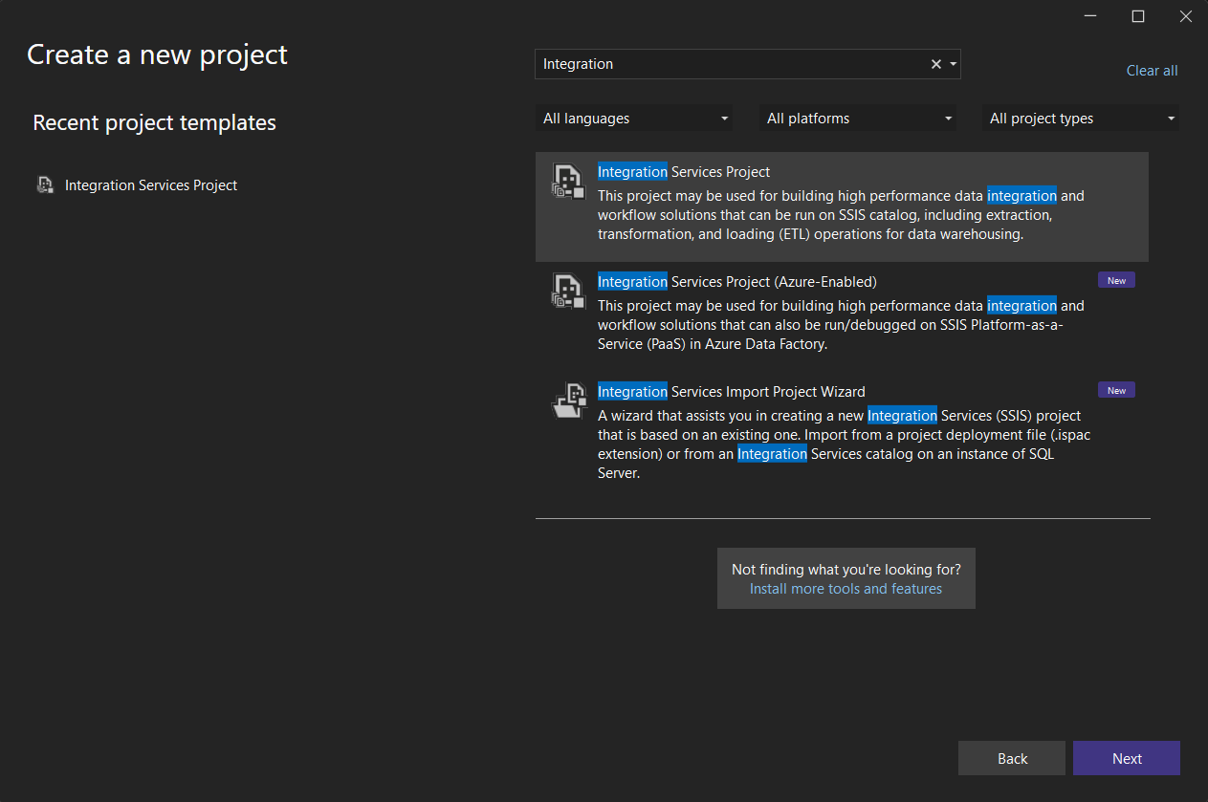

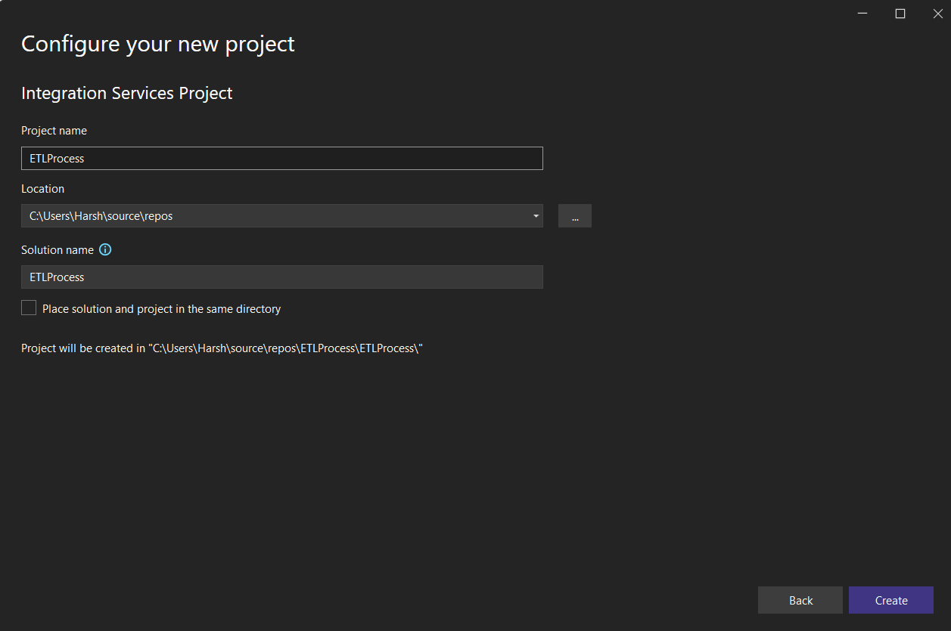

Environment consists of SQL Server Integration Services (SSIS)

Step 8) Right Click on Connection Manager in solution explorer and click on New Connection Manager

Add SSIS Connection Manager window appears

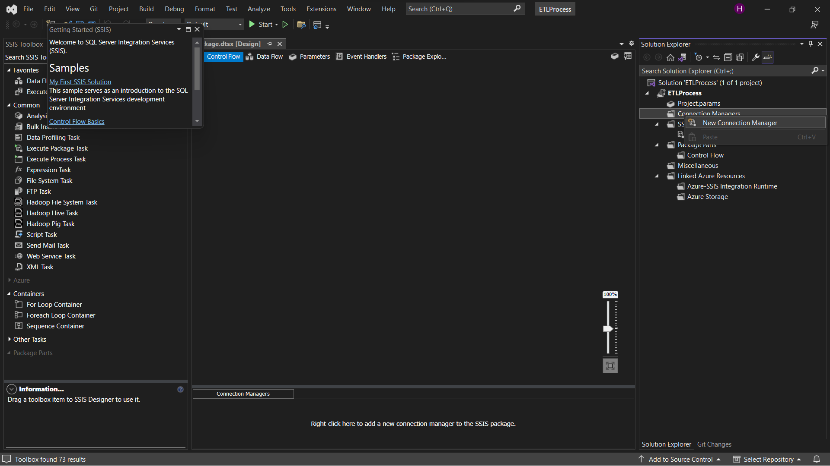

Step 9) Select OLEDB Connection manager and click on add

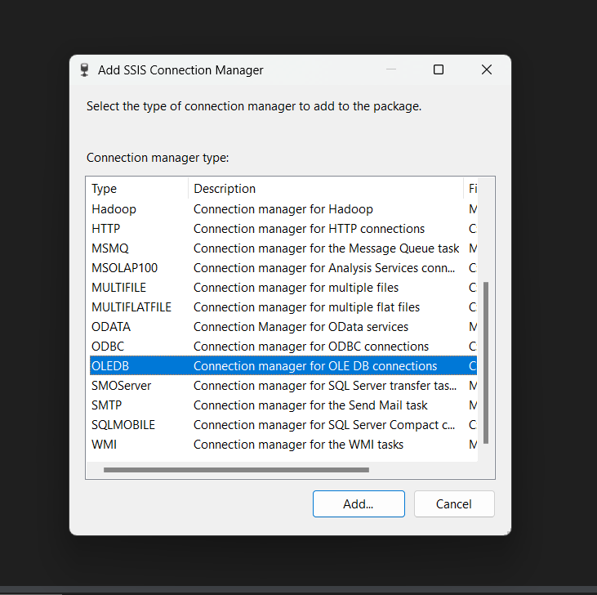

Step 10) Configure OLE DB Connection manager window appears -> Click on New

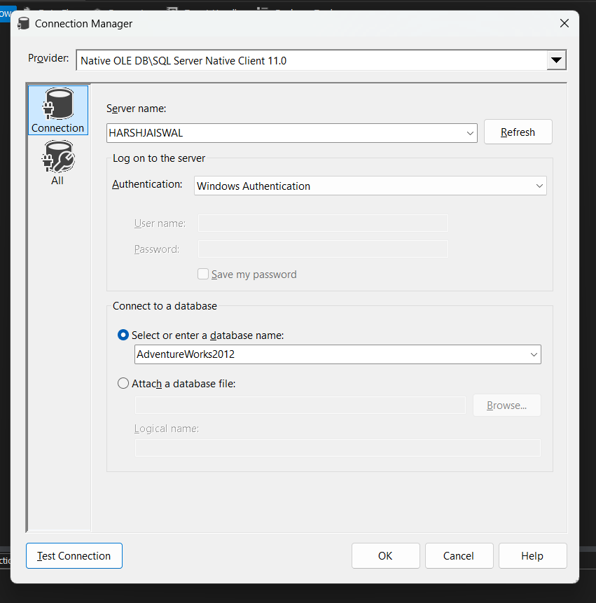

If test connection succeeded click on OK

Step 12) Click on OK

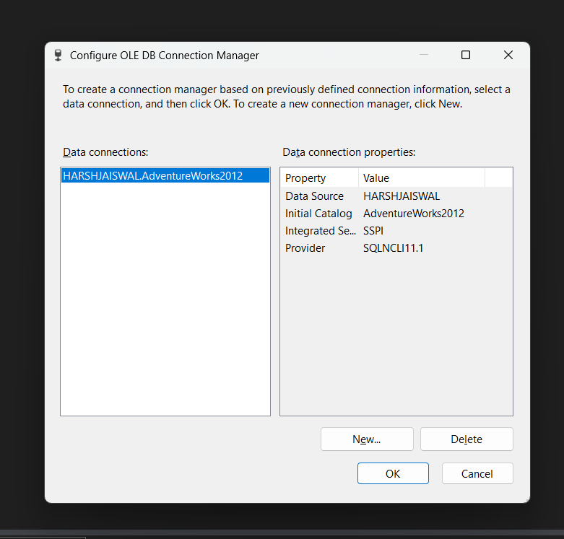

Connection is added to connection Manager

Step 13) Drag and Drop Data Flow in Control Flow tab

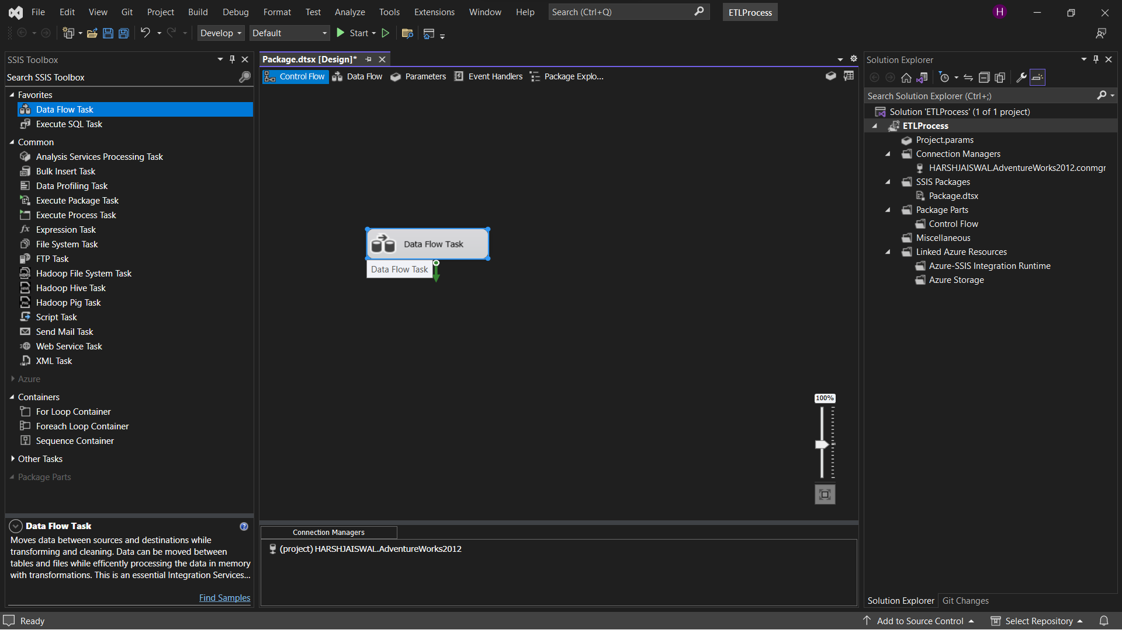

Step 14) Drag and Drop OLE DB source from Other Sources ad drop into Data Flow tab

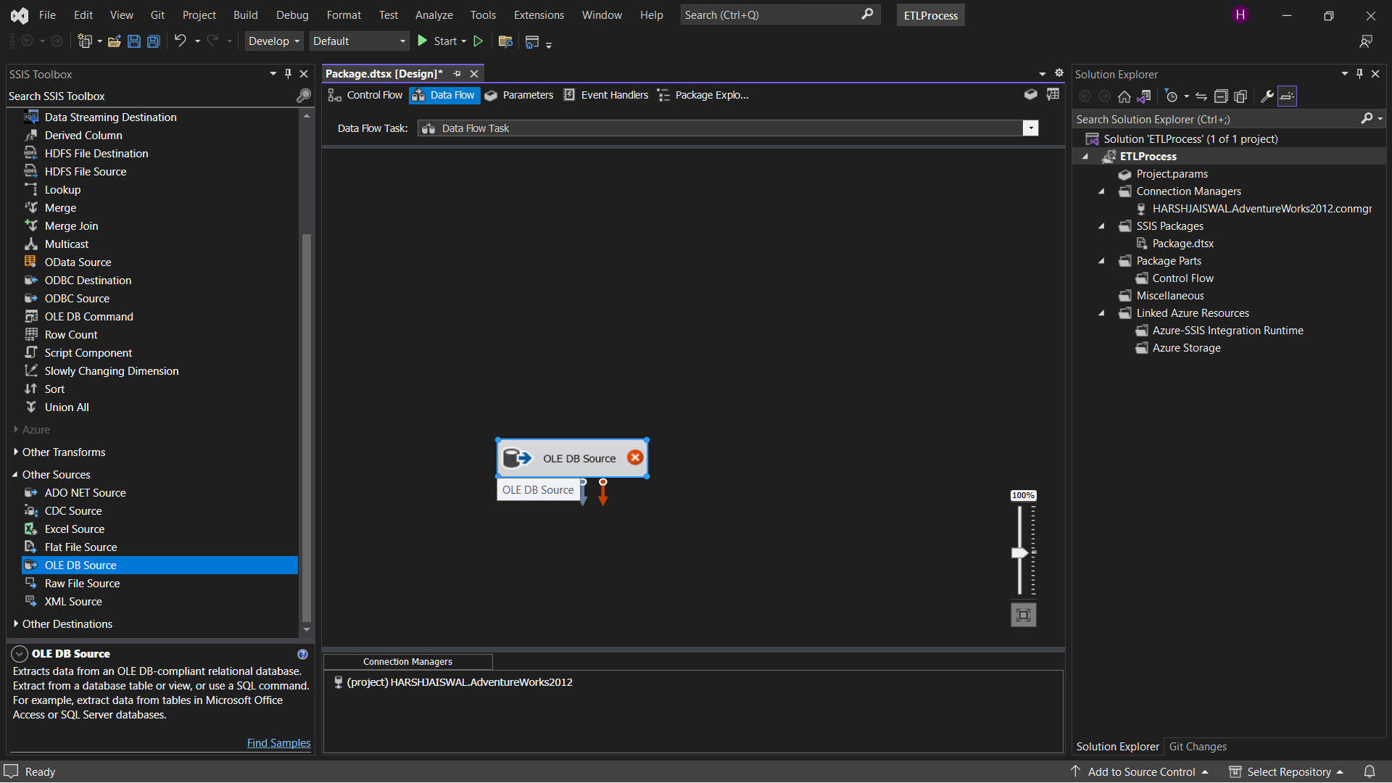

Step 15) Double Click on OLE DB source -> OLE DB Source Editor appears click on new to add aocnnection manager.

Select [Sales].[Store] table from the drop down -> OK

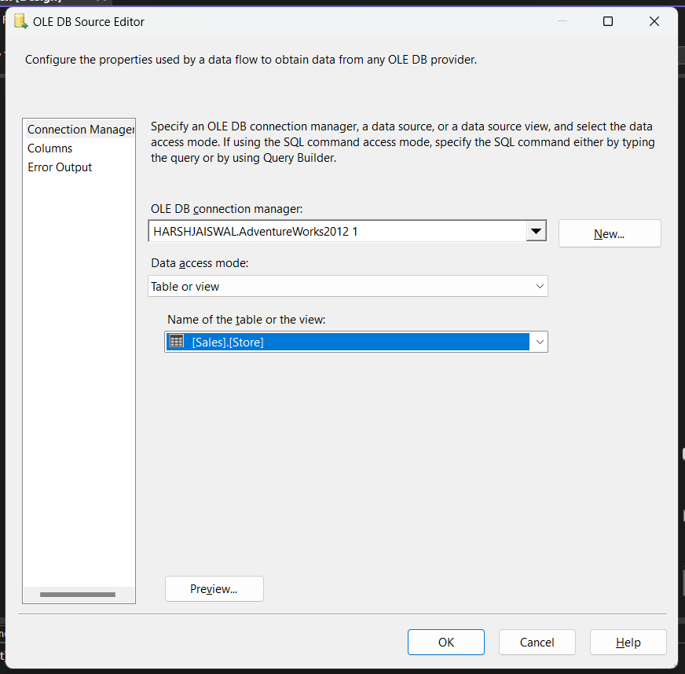

Step 16) Drag OLE DB destination in data flow tab and connect both

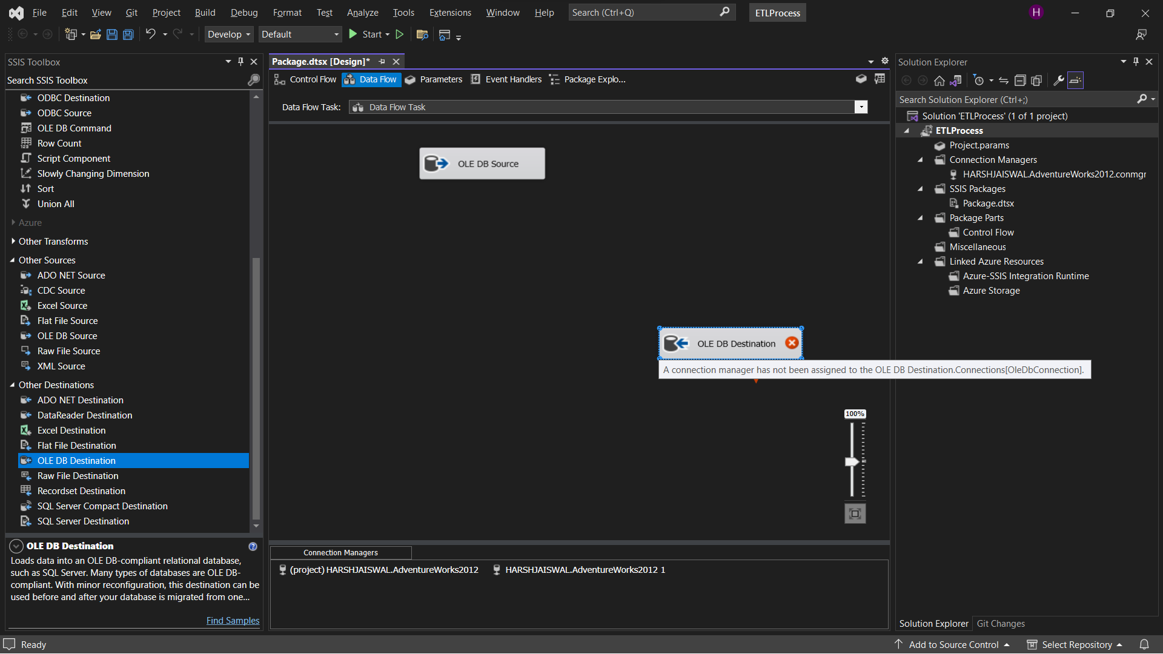

Step 17) Double click on OLE DB destination

Click on New to run the query to get [OLE DB Destination] in Name of the table or the view.

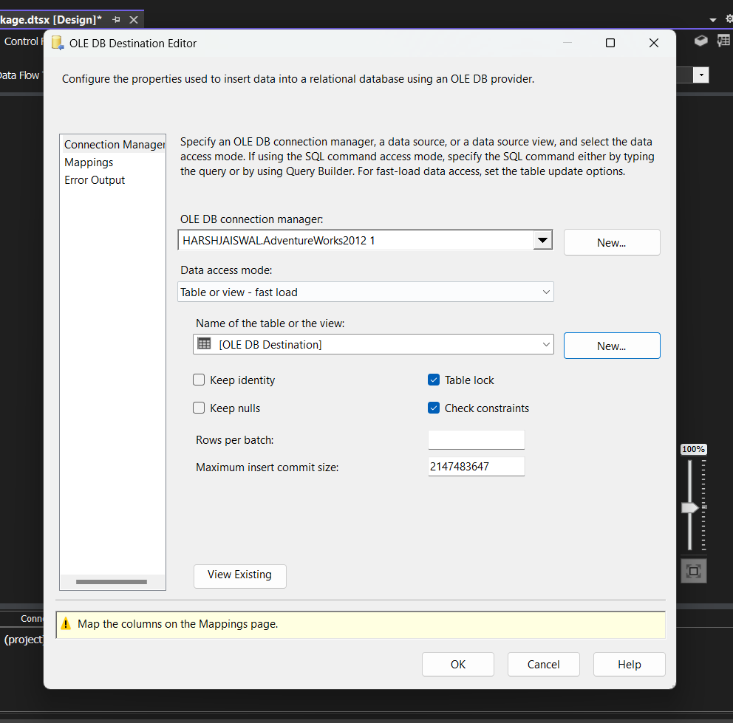

Click on OK

Step 18) Click on start

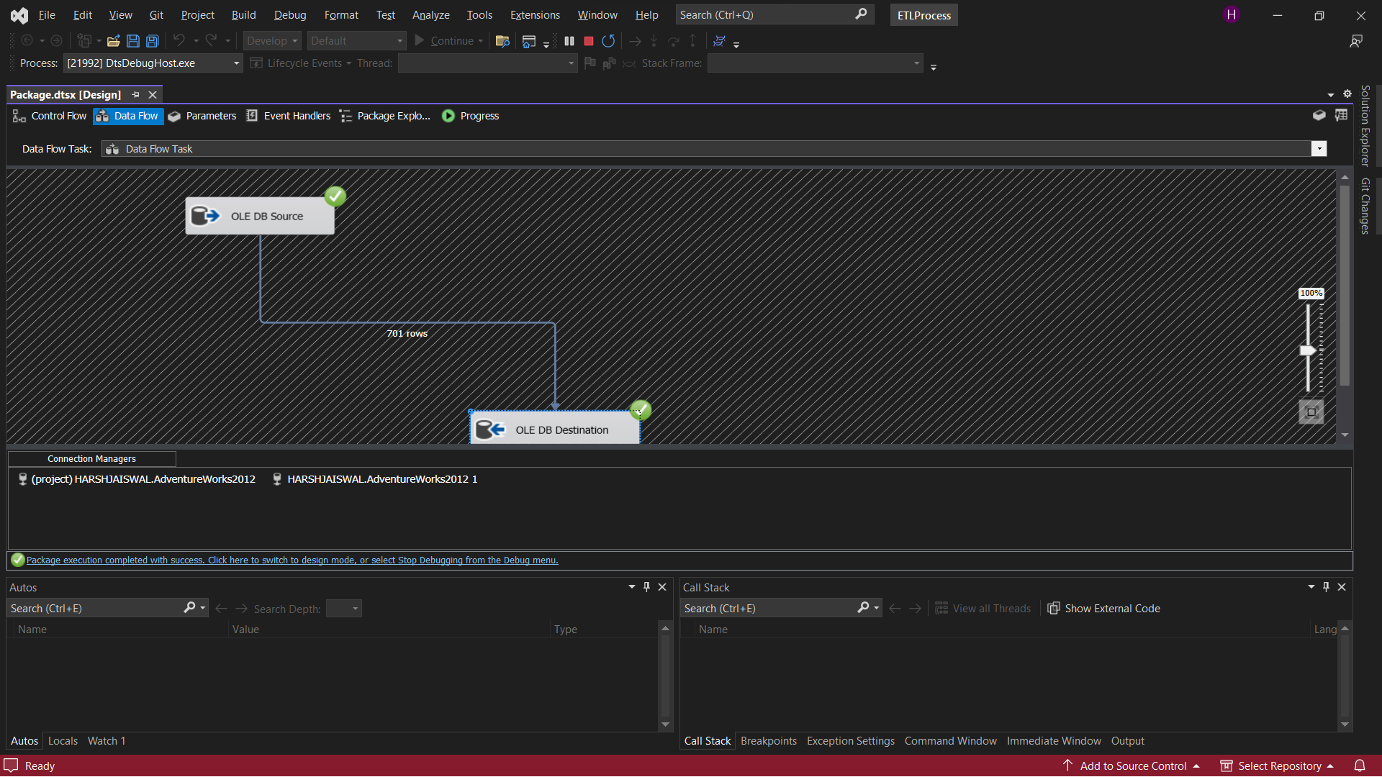

Step 19) Go to SQL Server Management Studio

In database tab -> Adventureworks -> Right click on [dbo].[OLE DB Destination] -> Script Table as -> SELECT To -> New Query Editor Window

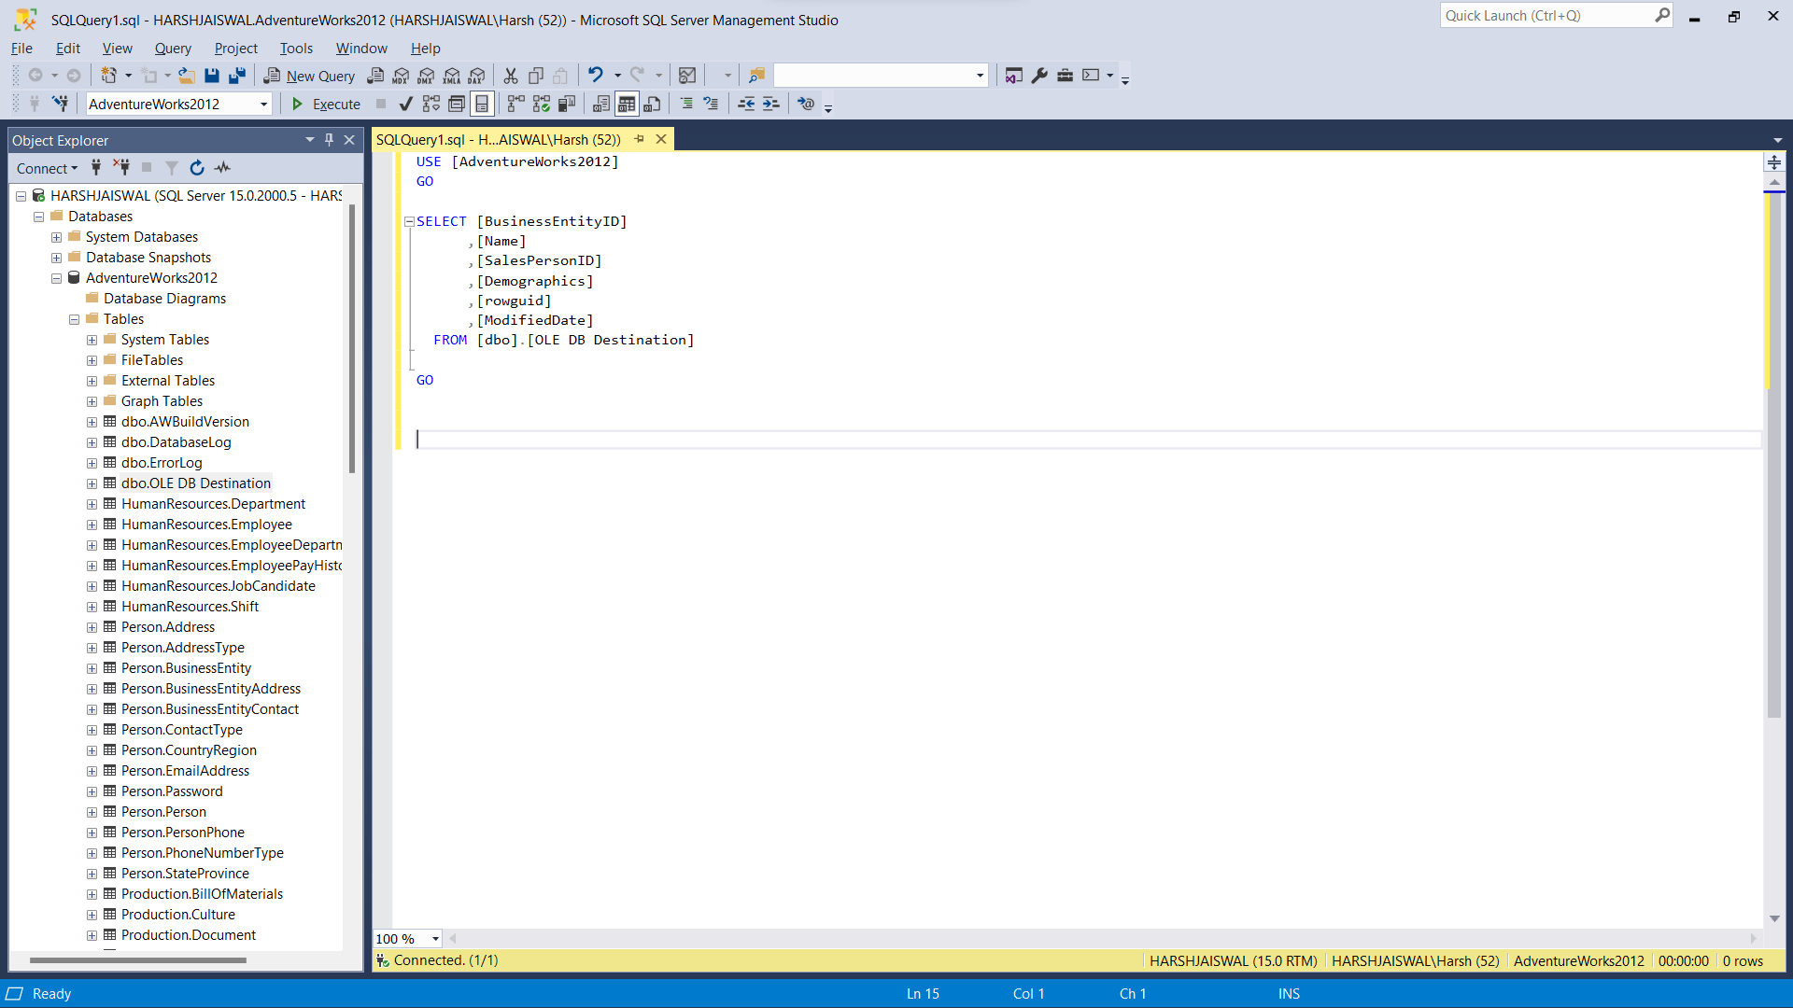

Step 20) Execute the query to get output

